GoPiGo Ultrasonic Info

The GoPiGo that I own is an older version, I was having a hard time find any correct information about the board, or even the build. I did finally find everything I needed here.

<https://github.com/DexterInd/GoPiGo>

Once I found this, I saw in the Arduino firmware how the ultrasonic worked, and thought - interesting, the expensive grove ultrasonic is really just the same as the HC-SR04 ultrasonics

The big difference is the number of pins used.

Grove uses a 4 pin connect, some of the connector use all 4 pins, others use only 3 of them.

The GoPiGo has the ultrasonic plugged into the A1 which at first glance would only use 3 of the 4 PINs (GND, VCC, A1). I was confused at first why the ultrasonic worked, but looking at the GoPiGo schematics, it appears that the 4th pin and the A1 are connected. And that explains how it works.

Mean while, I played around with some other ultrasonics, and soldered the trigger and echo pins together, and made a 3 wire ultrasonic with the cheap 99 cent HC-SR04 ultrasonics.

Here are some pictures:

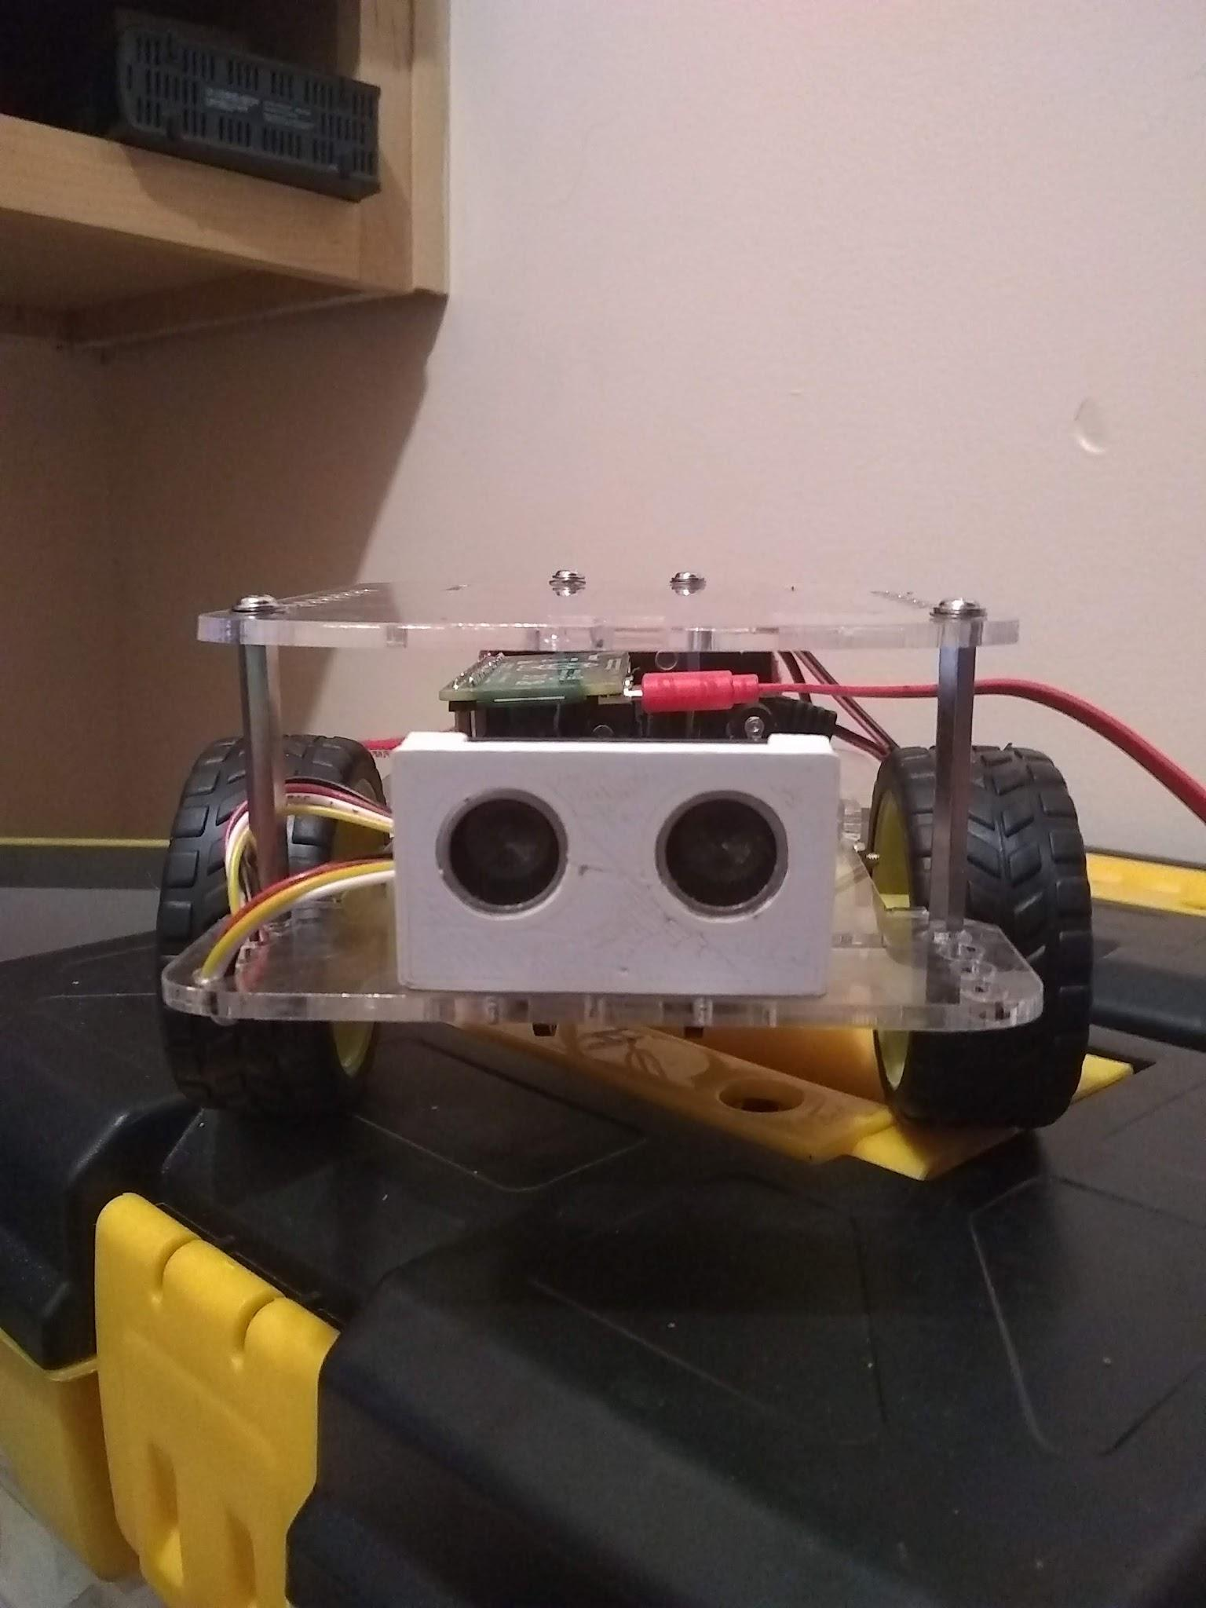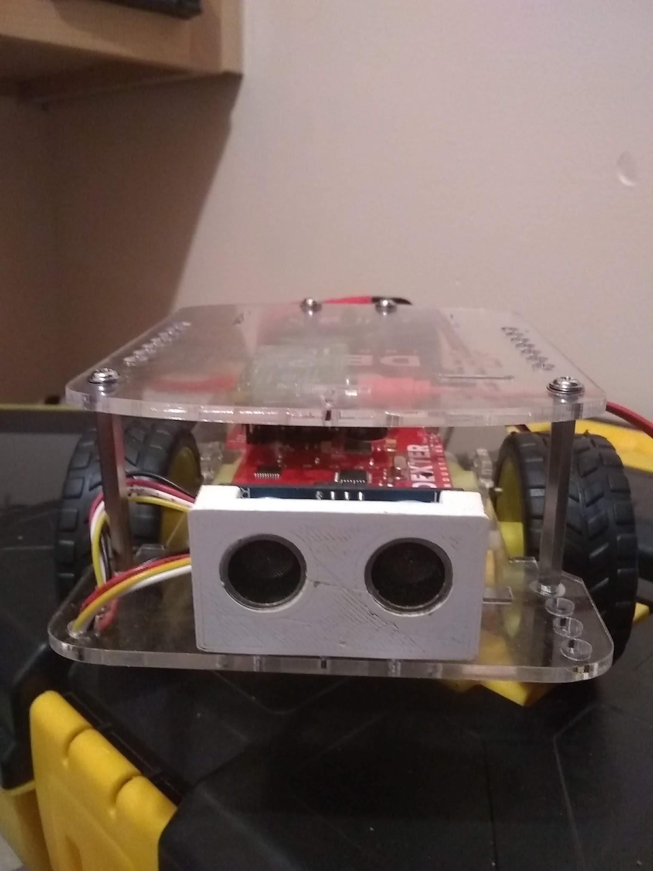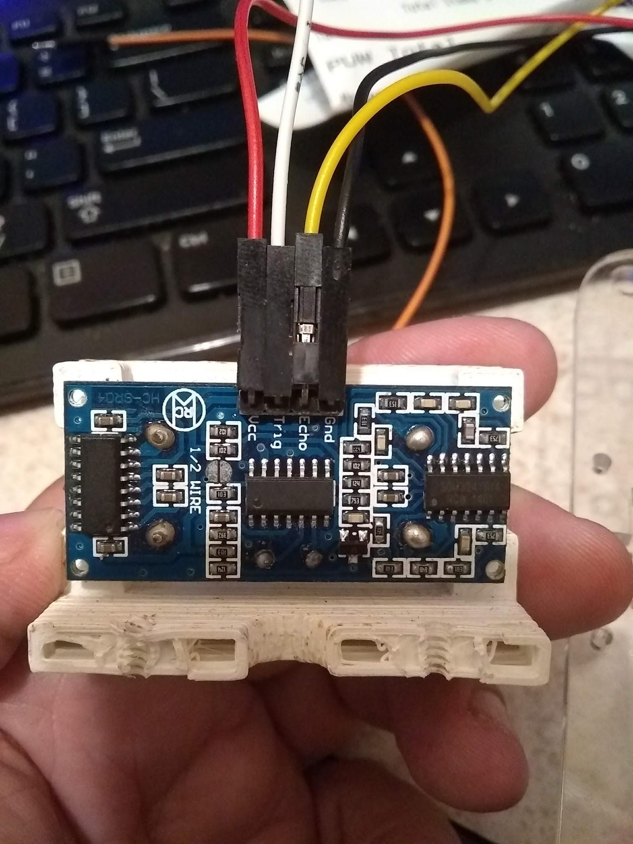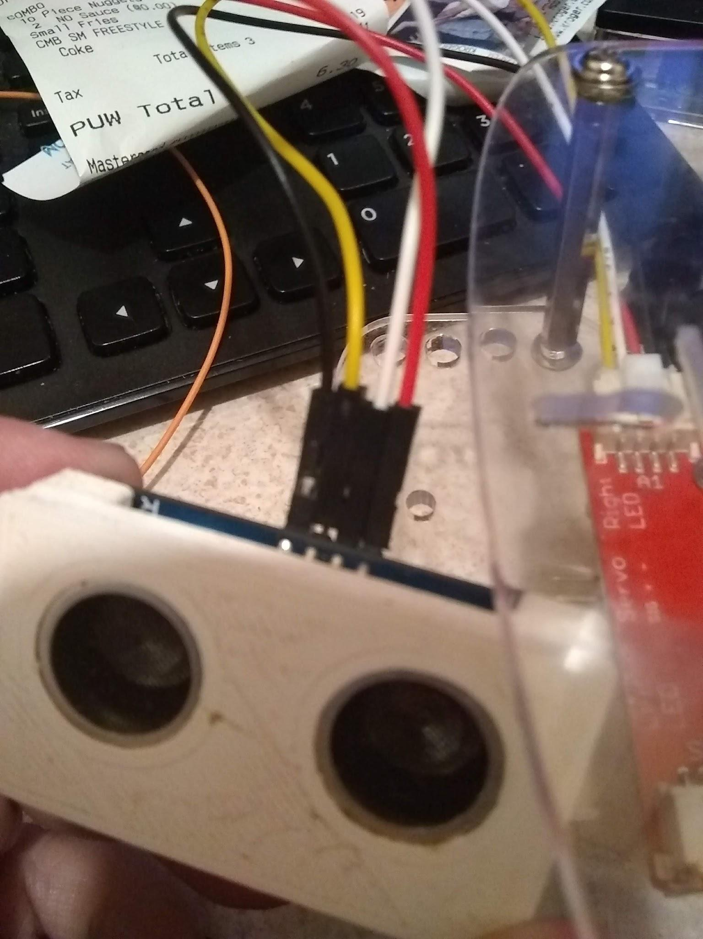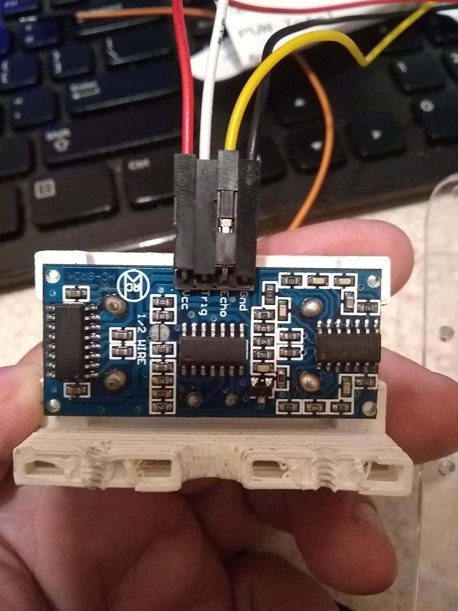

This is a HC-SR04 ultrasonic, it is like the one I used on the GoPiGo - it has a solder pad on the back that says “1/2 wire” - my tests seem to say that it doesn’t make a difference if that is soldered or not (I’m not sure what it is or why it’s there, I couldn’t find anything from searching)

Also pictured is a pretty common HC-SR04 ultrasonic, and you can see the differences between the two - both seem to function the same way and I’m not really sure what the differences are between them.

